Analysing Network Packet Stream Using Tcpdump
- TCPdump is a free & open-source packet analyzer tool & command-line utility.
- It is used for capturing the packets & inspect the network traffic
- It is basic used for troubleshooting network issues & security testing.
- We can capture non-TCP traffic such as UDP, ARP or ICMP.

Step 1: Update the System.
sudo apt update
Step 2: Install TCPdump on system.
sudo apt install tcpdump
Check the TCPdump version.
sudo tcpdump --version

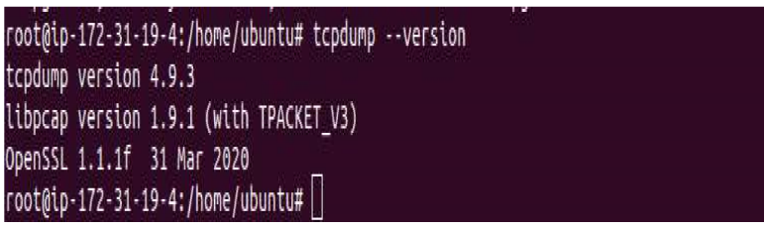

Step 3: TCPdump syntax & Examples.
Sudo tcpdump [options] [expression]
• To capture all packets.
Sudo tcpdump
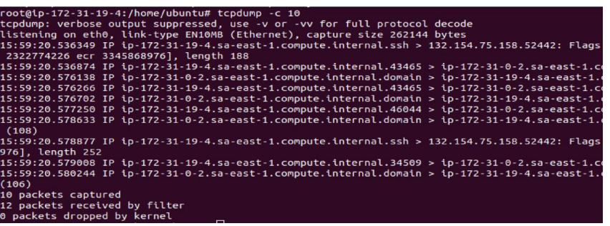
• To capture packets from a specific interface.
Sudo tcpdump -i eth0
• To capture only 10 packets.
Sudo tcpdump -c 10
• To list all the available interface.
Sudo tcpdump -D

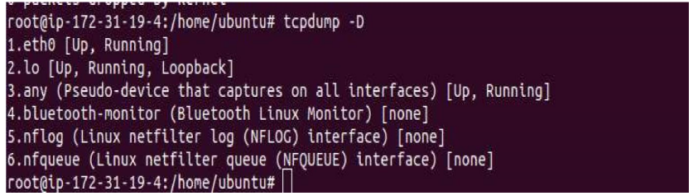

• To capture packets from any interface.
Sudo tcpdump -i any
• To use -n option to disable the translation.
Sudo tcpdump -n
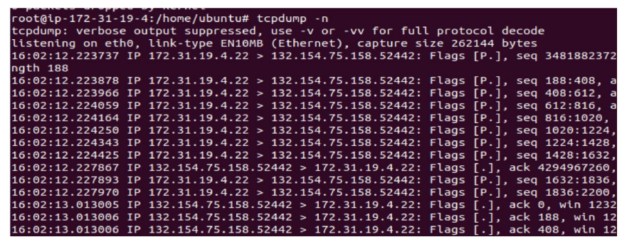
• To store capture network interface packets into a file.
Sudo tcpdump -n -i any > file.out
• To display the capture packets while saving to a file .
Sudo tcpdump -n -l | tee file.out
• To capture packect from a specific port number.
Sudo tcpdump -n port 22
Here is the command output.
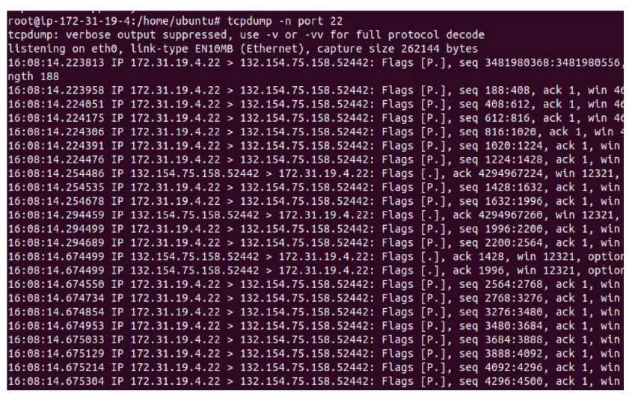

• To capture packets from a source ip.
Sudo tcpdump -n src host ip-address
• To capture the traffic coming from any source to port 80.
sudo tcpdump -n dst port 80
• To capture all HTTP traffic coming from a source IP address

